1st Northumbrian Brigade R.F.A. (T.F.)

The Introduction & page 7 of the ‘War History of the 1st Northumbrian Brigade’ book says:  ‘Prior to the formation of the Territorial Army in 1908 the Brigade was known as the 1st Northumberland Royal Garrison Artillery Volunteers. In 1908 it was converted into a Field Artillery Brigade, and was given the title of 1st Northumbrian Brigade R.F.A. (T.F.). It was based in Newcastle-upon-Tyne. | 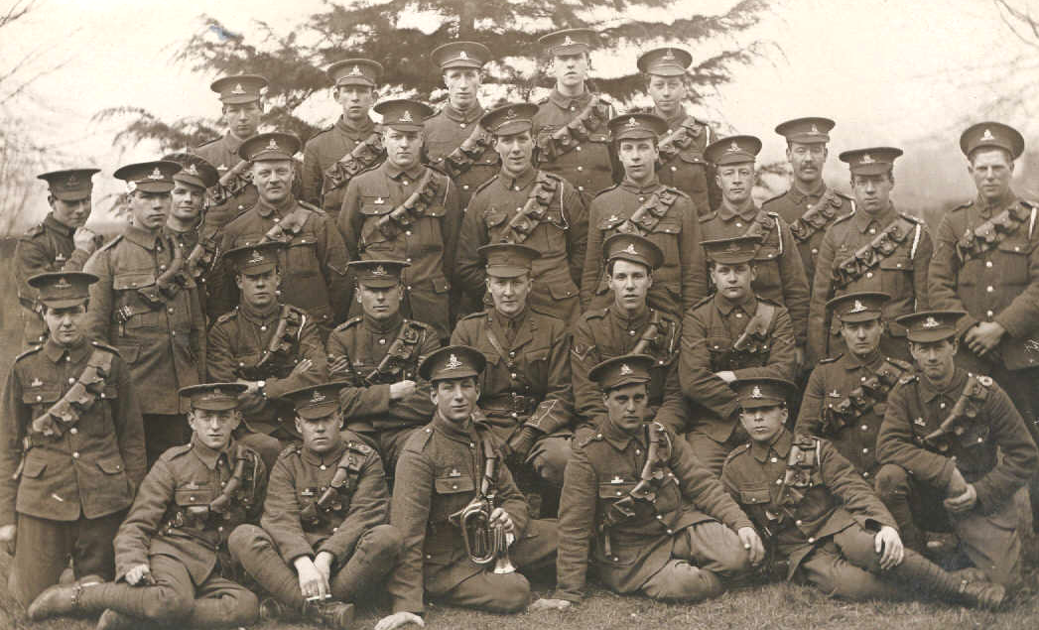
The Commanding Officer of the newly organised Brigade was Colonel Sir Philip Watts, and was composed of the usual three Batteries and Brigade Ammunition Column. The Headquarters and two Batteries, 1st and 2nd Northumberland, and the Ammunition Column, 1st Northumbrian, were quoted at the Drill Hall, Barrack Road, Newcastle-upon-Tyne, while the 3rd Northumberland Battery had a hall at the Elswick Ordnance Works on Scotswood Road, the personnel of the Battery being almost exclusively recruited from the men employed at the works.

In the old Volunteer days the Brigade sent out a Battery to South Africa in the war against the Boers. This Battery was composed of portions of all units, and was armed and equipped by the Elswick Ordinance Company. It was generally known as the Elswick Battery, a title, which was always held by the 3rd Battery, but the name officially given to it by the War Office was the South African Battery of the 1st Northumberland R.G.A. (Vols.). At the outbreak of the Great War in 1914 there were thirty-three N.C.O.s (Non-commissioned officers) and men, and three officers of the original Battery still serving in the Brigade. Of these, many of the men were too old to accompany the Brigade to France, but some, including three officers, Major H. S. Bell, D.S.O., Surgeon-Major Wreford, and Captain F. G. D. Johnston, did so, and served two campaigns with the Brigade.

The Brigade, therefore, held the distinction of being the only Territorial Artillery unit with an active service record previous to the war against Germany and her allies, the fact they were very proud of.

Under the new Territorial organisation the Brigade formed one of the Divisional Artillery Brigades of the Northumbrian Division, the headquarters of which were at Richmond, Yorkshire. In the six years prior to the outbreak of war great progress had been made in training and general efficiency under Colonel Sir Philip, and Lieutenant-Colonel A. G. Hancock, who succeeded him; and the Brigade had the reputation of been one of the most up-to-date Artillery units in the Territorial Force. This satisfactory result was largely due to the care with which recruiting was carried out, and with which officers were selected. In those days the choice of officers lay almost entirely with the Commanding Officer, and this made it possible to get together those who knew each other and their men in civil life, and who were keen on making themselves as efficient as circumstances would allow, and on maintaining the high reputation of the Brigade.

In August 1914, the Brigade consisted of 585 N.C.O.s and men and 22 officers. The Commanding Officer was Colonel G. Fenwick, who had succeeded Colonel Hadcock in April, at the termination of the latter's period of command. The Adjutant was Captain C. H. Ommanney R.F.A. (the author of the 1st Northumbrian Brigade's book), and the Battery Commanders were: 1st Battery, Major H. S. Bell, D.S.O., 2nd Battery, Captain C. H. Harrison; 3rd Battery, Captain F. G. D. Johnston; and Ammunition Column, Captain N. L. Parmeter.’

‘In the early days there was a good deal of 'changing about' amongst the officers, owing to various postings and promotions, which were made from time to time. It was not always easy to fit people in, and we wanted to keep everybody as far as possible in their original units. Captain Johnston was taken from the Elswick Battery very soon to act as temporary Staff Captain R.A., which left the whole burthen of mobilising the Battery to Lieutenant Caldecott. As Captain Johnston did not return, Captain Meagher was posted to command the Battery, and Lieutenant Wilkinson took over the B.A.C. (Brigade Ammunition Column); Lieutenant T. V. G. Elliott was employed as A.D.C (Aide de Camp) to the C.R.A. (Commanding Royal Artillery) from the beginning; and Captain Parmeter was promoted to Major and given the 2nd Battery. On Captain Johnston rejoining, he was promoted to Major, and Meagher took the B.A.C., Wilkinson eventually taking out the 2nd Battery to France.

Early in 1915 Lieutenant Pybus left the 1st Battery, and joined the Headquarters to act as Orderly Officer to the Colonel and as understudy to the Adjutant, who hourly expected to be wafted to other scenes. These arduous duties had up to then been performed by Lieutenant and Hon. Major J. Graham, T.D., an officer of more than thirty years' service with the Brigade, whose advice and experience had been of the greatest assistance to the Adjutant, but his age unfortunately precluded him accompanying the Brigade overseas.

Major Graham, however, did valuable work in the Territorial County Association in looking after the Brigade funds and its interests generally, in keeping in touch with the relatives of officers and men who became casualties and helping them when necessary. He also collected and took charge of all the Brigade records and documents, which were sent home from the Front from time to time, and without which the compilation of this history would have been impossible. His work for the Brigade, therefore, was of great value, even though, to his disappointment, he was unable to accompany it on active service.’

